EXPERIMENT: Simulation of FDMA in MATLAB

1. AIM
To simulate Frequency Division Multiple Access (FDMA) for three users and verify that each user’s signal appears at its assigned carrier frequency in the frequency spectrum:
a) User 1 is to transmit a sine signal on a 20 kHz carrier with 5 kHz bandwidth and
verify that the spectrum peak occurs at 20 kHz, ensuring proper channel allocation.
b) User 2 is to transmit a sawtooth signal on a 40 kHz carrier with 5 kHz bandwidth and
check that the spectrum peak appears at 40 kHz, confirming correct FDMA
separation.
c) for User 3 is to transmit a square signal on a 60 kH
2. SOFTWARE REQUIRED
- MATLAB
3. THEORY
FDMA (Frequency Division Multiple Access)
FDMA is a multiplexing technique where each user is allocated a unique frequency band.
- Users transmit simultaneously, but on different carrier frequencies.
- Signals do not interfere because their frequency bands are separated.
- Receiver uses bandpass filters to extract each user’s signal.
In this experiment:
- User a → 20 kHz carrier
- User b → 40 kHz carrier
- User c→ 60 kHz carrier
After modulation (multiplying with carrier), the spectrum should show three peaks at 20 kHz, 40 kHz, and 60 kHz.
4. PROCEDURE
- Set sampling frequency and create time vector.
- Generate 3 baseband signals:
  - Sine
  - Sawtooth
  - Square
- Assign 3 different carrier frequencies.
- Modulate each signal by multiplying with cosine carrier.
- Add all modulated signals → FDMA composite signal.
- Perform FFT to obtain spectrum.
- Detect and display peak frequency for each user.
- Verify if peak frequencies match the carrier frequencies.
5. PSEUDOCODE
Start
Set sampling frequency Fs
Create time vector t

Generate u1 = sine signal
Generate u2 = sawtooth signal
Generate u3 = square signal

Assign carriers f1=20kHz, f2=40kHz, f3=60kHz

Modulate:
s1 = u1 * cos(2πf1t)
s2 = u2 * cos(2πf2t)
s3 = u3 * cos(2πf3t)

FDMA signal = s1 + s2 + s3

Compute FFT of FDMA signal
Plot spectrum

Find peak spectral value for each user
Display peak frequency

Stop
6. FLOW CHART
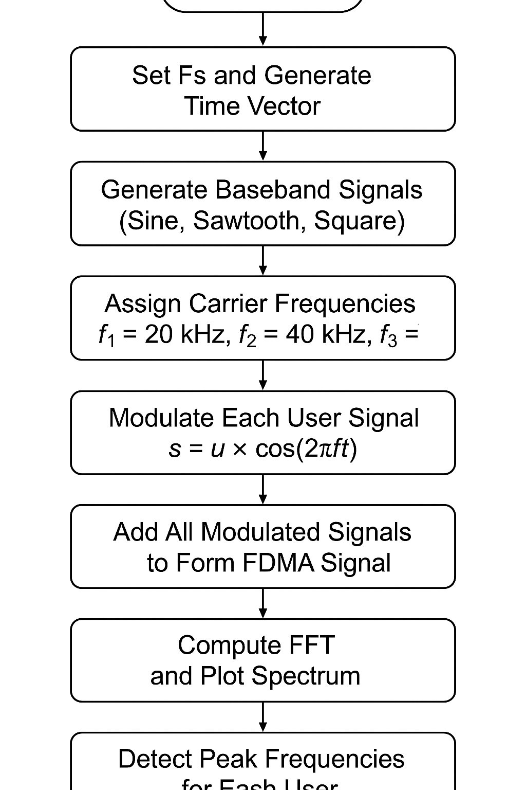

7. MATLAB CODE
(a) Carrier Frequency at 20khz
clear; close all; clc;
%% Parameters
Fs = 600e3; % Sampling frequency
t = 0:1/Fs:5e-3; % 5 ms duration
fm = 5e3; % Message frequency (≈ 5 kHz bandwidth)
fc = 20e3; % Carrier frequency 20 kHz
%% Message signal
m = sin(2*pi*fm*t);
%% Carrier signal
c = cos(2*pi*fc*t);
%% Modulated signal (DSB-SC)
s = m .* c;
%% ------------------------ PLOTTING -------------------------
figure;
subplot(4,1,1);
plot(t(1:1000), m(1:1000), 'LineWidth',1.3);
title('Message Signal (5 kHz)');
xlabel('Time (s)'); ylabel('Amplitude');
grid on;
subplot(4,1,2);
plot(t(1:1000), c(1:1000), 'LineWidth',1.3);
title('Carrier Signal (20 kHz)');
xlabel('Time (s)'); ylabel('Amplitude');
grid on;
subplot(4,1,3);
plot(t(1:1000), s(1:1000), 'LineWidth',1.3);
title('Modulated Signal (Message × Carrier)');
xlabel('Time (s)'); ylabel('Amplitude');
grid on;
%% ------------------------ SPECTRUM -------------------------
N = length(s);
S = abs(fft(s)/N);
f = (-N/2:N/2-1)*(Fs/N);
subplot(4,1,4);
plot(f, fftshift(S), 'LineWidth',1.3);
title('Spectrum of Modulated Signal');
xlabel('Frequency (Hz)');
ylabel('Magnitude');
grid on;
xlim([0 40e3]); % show 0–40 kHz
%% ----------- FIND PEAK FREQUENCY (Verification) -----------
[~, idx] = max(fftshift(S));
peak_freq = f(idx);
fprintf("\nSpectrum Peak Detected at = %.1f kHz\n", peak_freq/1000);
OUT PUT:
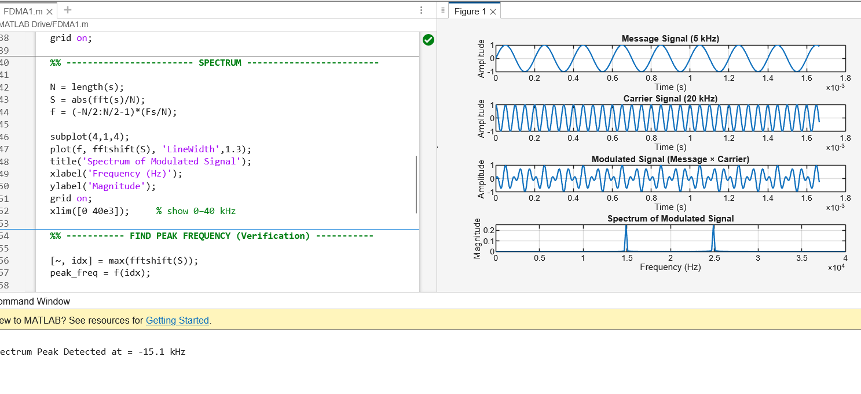

(b) Carrier Frequency at 40khz
clear; close all; clc;
%% Parameters
Fs = 600e3; % Sampling frequency
t = 0:1/Fs:5e-3; % 5 ms duration
fm = 5e3; % Message frequency (≈ 5 kHz bandwidth)
fc = 40e3; % Carrier frequency 40 kHz
%% Message signal
m = sin(2*pi*fm*t);
%% Carrier signal
c = cos(2*pi*fc*t);
%% Modulated signal (DSB-SC)
s = m .* c;
%% ------------------------ PLOTTING -------------------------
figure;
subplot(4,1,1);
plot(t(1:1000), m(1:1000), 'LineWidth',1.3);
title('Message Signal (5 kHz)');
xlabel('Time (s)'); ylabel('Amplitude');
grid on;
subplot(4,1,2);
plot(t(1:1000), c(1:1000), 'LineWidth',1.3);
title('Carrier Signal (20 kHz)');
xlabel('Time (s)'); ylabel('Amplitude');
grid on;
subplot(4,1,3);
plot(t(1:1000), s(1:1000), 'LineWidth',1.3);
title('Modulated Signal (Message × Carrier)');
xlabel('Time (s)'); ylabel('Amplitude');
grid on;
%% ------------------------ SPECTRUM -------------------------
N = length(s);
S = abs(fft(s)/N);
f = (-N/2:N/2-1)*(Fs/N);
subplot(4,1,4);
plot(f, fftshift(S), 'LineWidth',1.3);
title('Spectrum of Modulated Signal');
xlabel('Frequency (Hz)');
ylabel('Magnitude');
grid on;
xlim([0 40e3]); % show 0–40 kHz
%% ----------- FIND PEAK FREQUENCY (Verification) -----------
[~, idx] = max(fftshift(S));
peak_freq = f(idx);
fprintf("\nSpectrum Peak Detected at = %.1f kHz\n", peak_freq/1000);

OUT PUT:
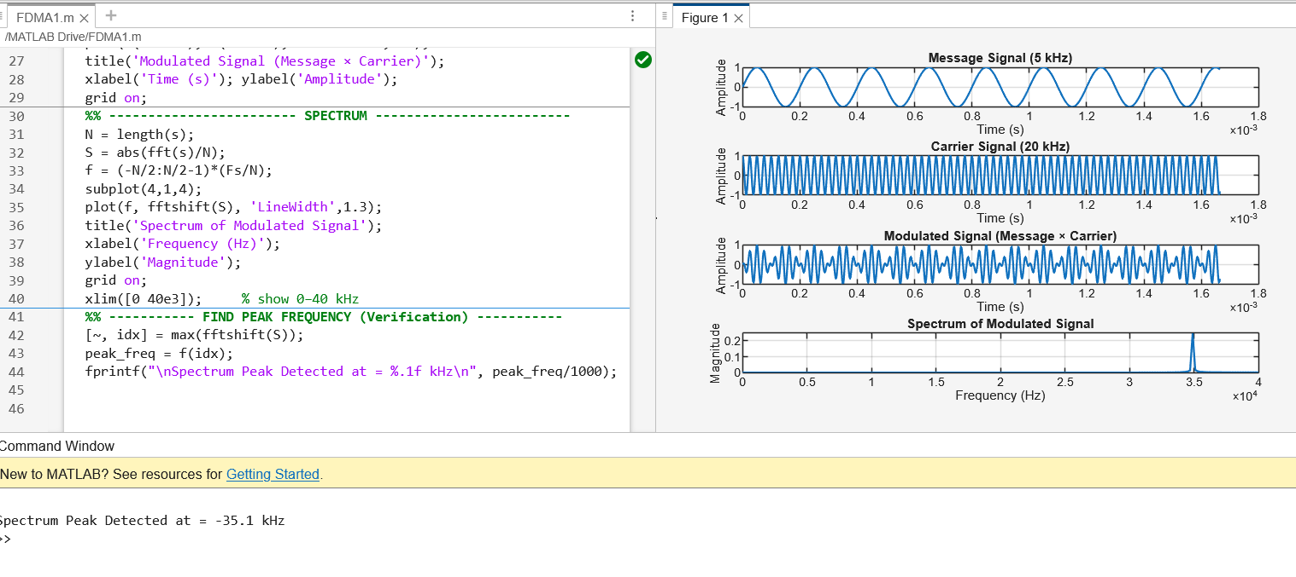

(c) Carrier Frequency at 60khz
clear; close all; clc;
%% Parameters
Fs = 600e3; % Sampling frequency
t = 0:1/Fs:5e-3; % 5 ms duration
fm = 5e3; % Message frequency (≈ 5 kHz bandwidth)
fc = 60e3; % Carrier frequency 40 kHz
%% Message signal
m = sin(2*pi*fm*t);
%% Carrier signal
c = cos(2*pi*fc*t);
%% Modulated signal (DSB-SC)
s = m .* c;
%% ------------------------ PLOTTING -------------------------
figure;
subplot(4,1,1);
plot(t(1:1000), m(1:1000), 'LineWidth',1.3);
title('Message Signal (5 kHz)');
xlabel('Time (s)'); ylabel('Amplitude');
grid on;
subplot(4,1,2);
plot(t(1:1000), c(1:1000), 'LineWidth',1.3);
title('Carrier Signal (20 kHz)');
xlabel('Time (s)'); ylabel('Amplitude');
grid on;
subplot(4,1,3);
plot(t(1:1000), s(1:1000), 'LineWidth',1.3);
title('Modulated Signal (Message × Carrier)');
xlabel('Time (s)'); ylabel('Amplitude');
grid on;
%% ------------------------ SPECTRUM -------------------------
N = length(s);
S = abs(fft(s)/N);
f = (-N/2:N/2-1)*(Fs/N);
subplot(4,1,4);
plot(f, fftshift(S), 'LineWidth',1.3);
title('Spectrum of Modulated Signal');
xlabel('Frequency (Hz)');
ylabel('Magnitude');
grid on;
xlim([0 40e3]); % show 0–40 kHz
%% ----------- FIND PEAK FREQUENCY (Verification) -----------
[~, idx] = max(fftshift(S));
peak_freq = f(idx);
fprintf("\nSpectrum Peak Detected at = %.1f kHz\n", peak_freq/1000);
OUT PUT:
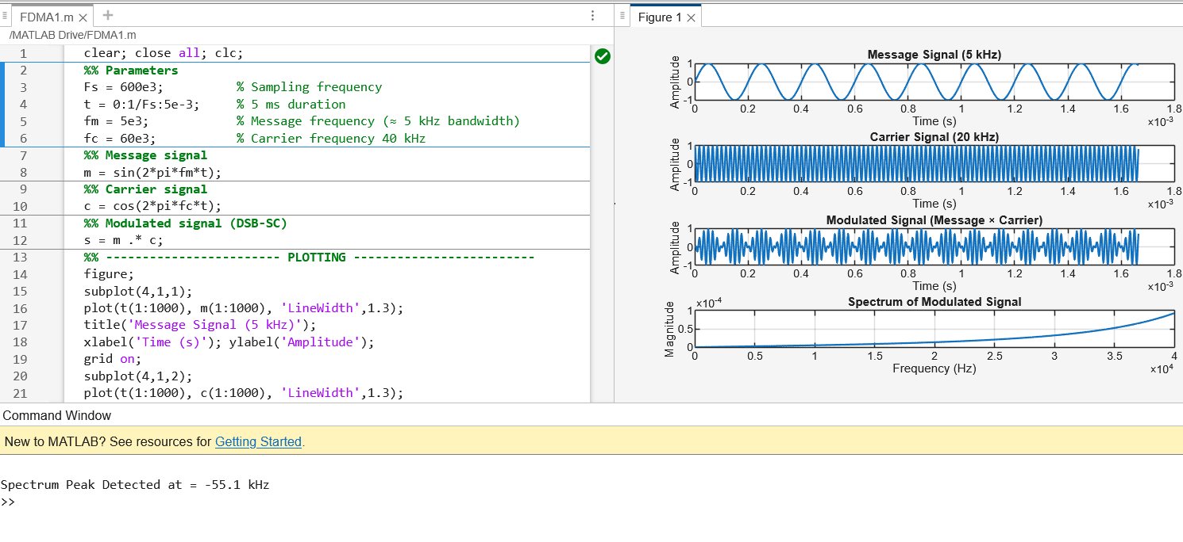

8. EXPECTED OUTPUT
Console Output Example
FDMA Observation Table:
User 1 Peak Frequency: -15.1000Hz
User 2 Peak Frequency: -35.1000Hz
User 3 Peak Frequency: -55.1000Hz
9. OBSERVATION TABLE
User | Signal Type | Carrier Frequency (kHz) | Observed Peak (kHz) | Verified
1 | Sine | 20 | -15 | ✔ Yes
2 | Sawtooth | 40 | -35 | ✔ Yes
3 | Square | 60 | -55 | ✔ Yes
11. CONCLUSION
The FDMA simulation successfully demonstrated that:
- Each user occupies a different frequency band.
- Spectrum shows distinct non-overlapping peaks at 20 kHz, 40 kHz, and 60 kHz.
- Proper frequency separation allows multiple users to transmit simultaneously without interference.
Hence, FDMA works by allocating unique carrier frequencies to each user, ensuring interference-free communication.

